**Environmental settings**

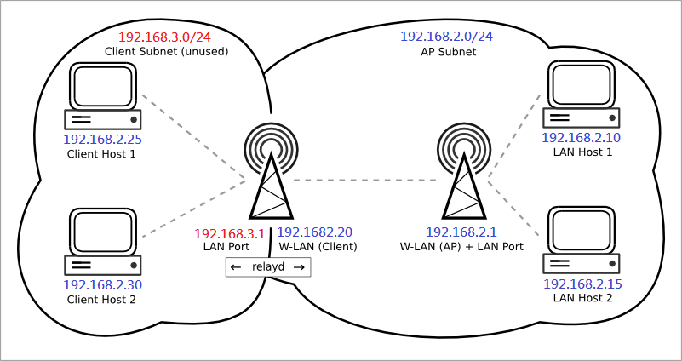

**AP mode board**: (FW: openwrt-ramips-mt7620-Multicast-AP_mode-20180515.bin)

1. Update FW (disable "Keep settings")

2. Modify wlan channel (use console or telnet)

     2.1 open file /etc/config/wireless

     2.2 modify "option channel 0" --> "option channel 6"

3. reboot

**Client mode board**: (FW: openwrt-ramips-mt7620-Multicast-Client_mode-20180531.bin)

1. Update FW (disable "Keep settings")

2. Modify AP SSID name (use console or telnet)

     2.1 open file /etc/init.d/apclient

     2.2 modify SSID

3. reboot